ACTIVITY 4 | I Spy with My Little Eye
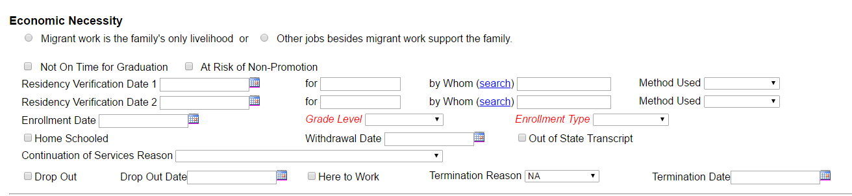
Instructions: | Let’s play a game of I Spy! Circle everything you can spot that is new on the Update Enrollment History Information screen and the Add Student Course History Information screen below.

